**Functional Interface**

* A **Functional Interface** is an interface that has **a single abstract method**, it includes - **Runnable, Callable, Comparable, Comparator, TimerTask** and etc. Prior to Java 8, they were known as **"Single Abstract Method" (SAM)** types.

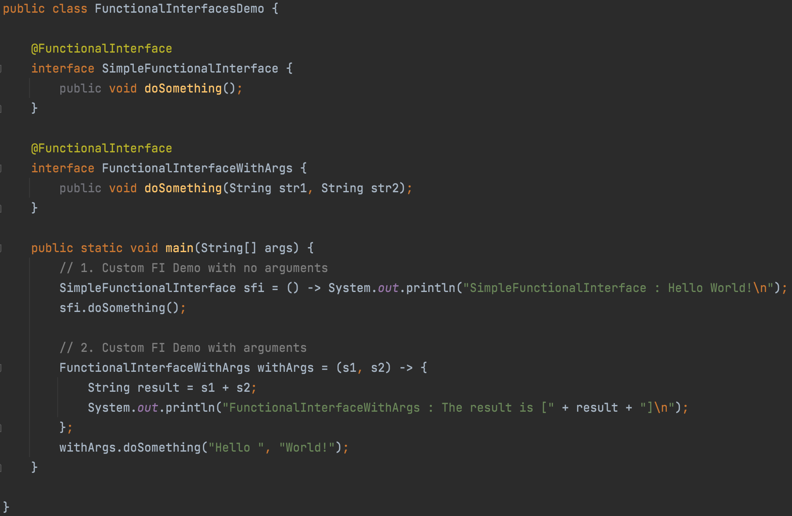

**Lambda Expressions**

* **Lambda expressions are anonymous functions that instantiate interfaces with a single method**.
* Lambda expressions can only appear in places where they will be **assigned to a variable whose type is a functional interface**.
* Using lambda expression doesn't give any performance benefits, it only reduces the amount of code.

One of the most useful functional interfaces added in Java 8 is the **Predicate interface**, which has **single boolean method named test**, that we can use to wrap up conditional processing.

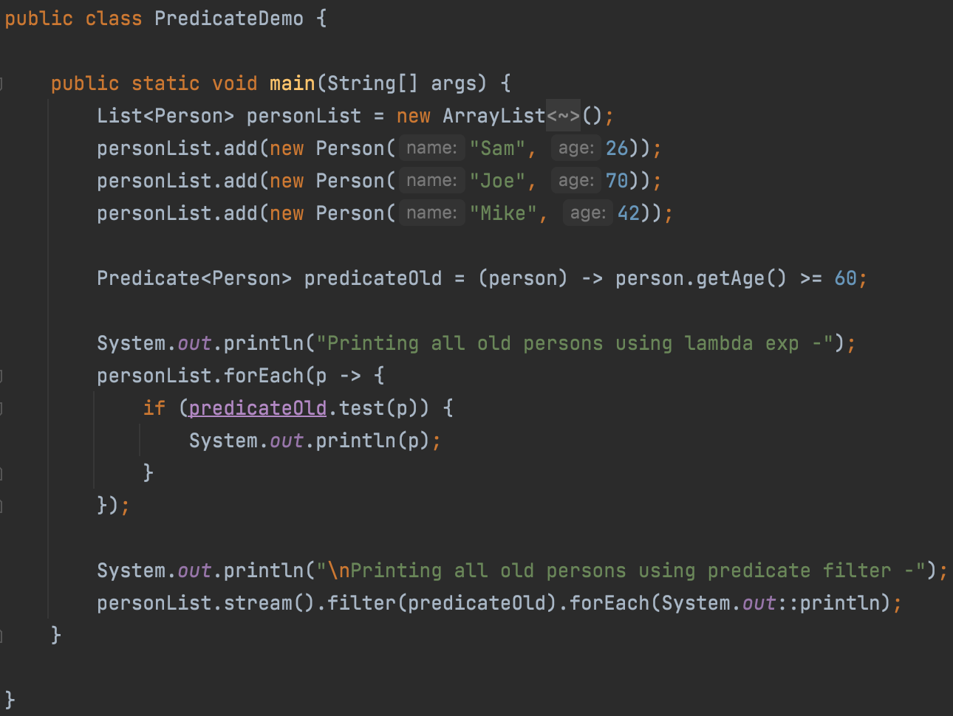

**DateTime API**

* Java 8 includes a completely new set of APIs for managing date and time values.
* **DateTime API classes that hold the data are all immutable and thread-safe**.
* Unlike Date API in earlier Java versions, java 8 Date API uses 1 for January and 12 for December.

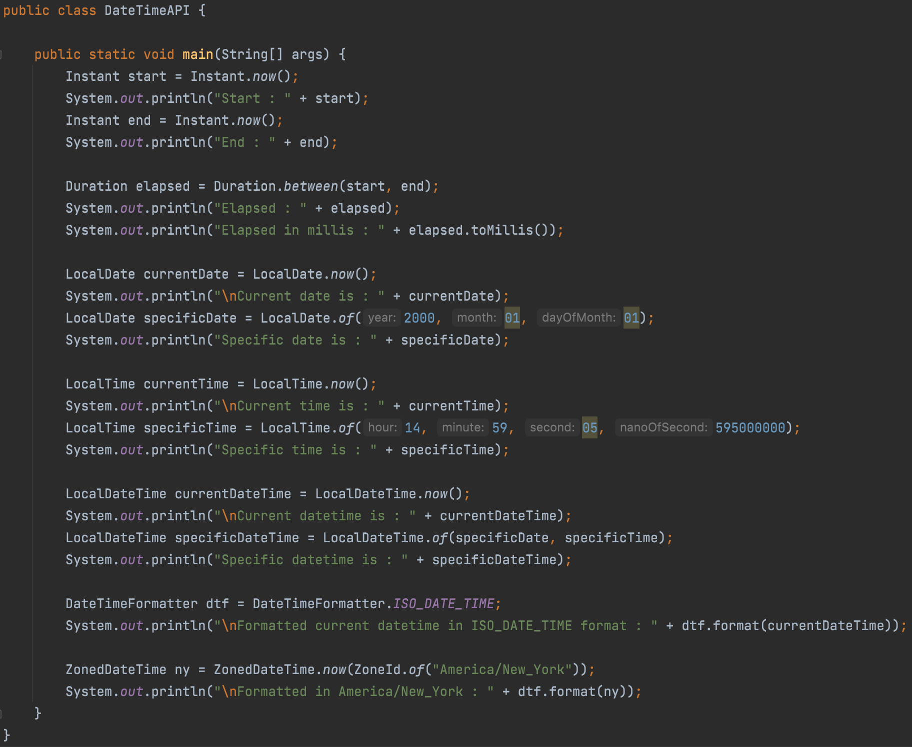

**Default and Static methods**

